Guía
Inactivate a mass amount of older 2015-2017 customer data.
With regards to changing the status based on customer identification numbers from Active to Not Active. This is what we found in NetSuite regarding the Scripts.
Based on the naming and last date modified it appears to be the JavaScript Files used last. (See Below Print Screen).
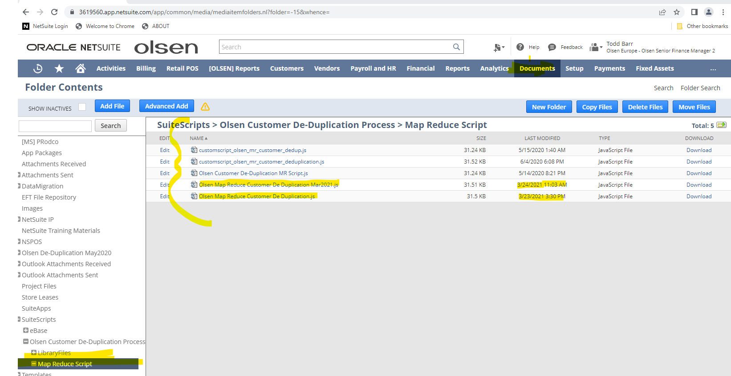
We will need support to execute the scripts.

Questions:
- Flush out the past duplicates e.g. For all “Date of Last Sale” from 2015-2018, Large data set. Changing 10,000+ from Active to Inactive.
FROM PS: Is this for transactions? it mentions "Date of Last Sale". If not, and this is for customers, then NetSuite default "Duplicate Merge Detection" (whatever the official verbiage is) should work with NSPOS out of the box, unless Olsen has a specific reason it will not.

- Stop Additional Duplicated items from being entered “email addresses” a specific field that is a key mandatory field going forward.
FROM PS: This says "items" but references email addresses, so again I am thinking this is for customers? I believe Olsen has a script in place in NSPOS to prevent them from entering Duplicate Email Addresses already. Is that script no longer working as expected? In ERP that would be handled by native Duplicate Detection.
Would you mind explaining this in more detail?

- Merge/Purge new duplicates entered in NetSuite after last successful clearing back in March 2021.
FROM PS: Yes, the out-of-the-box Duplicate Detection functionality in ERP should clean up POS also, again assuming nothing "strange" was done like someone ran scripts in ERP to do it themselves previously instead of using native functionality. Note that due to the number of Database changes this may cause, I would highly recommend this is tested in an updated SB environment first before running on production.

